|  |  |
| --- | --- |
| **EGC Upward & Onward Logo** | Student Name _______________________    **Eastern Goldfields College**  Mathematics Essentials U3&4 2018  Test 31 |
| **Working Time: 60 minutes** | **Total Marks: 51 marks** |

**Show all working where necessary to maximize your marks.**

**Question 1 (3 marks: 1, 2)**

a) Given the four scatter graphs below, which one shows the weakest linear relationship? **[1]**

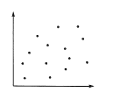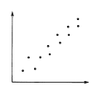 A B

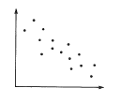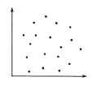

C D

b) Match each of the scatter graphs with one of these descriptions: **[2]**

1. Sales of flyspray and the temperature Graph ______
2. Frequency of playing sport and fitness level Graph ______
3. Foot length and intelligence Graph ______
4. Test results and hours spent watching TV Graph ______

**Question 2 (2 marks)**

The following graph shows the motion of a runner on a path.

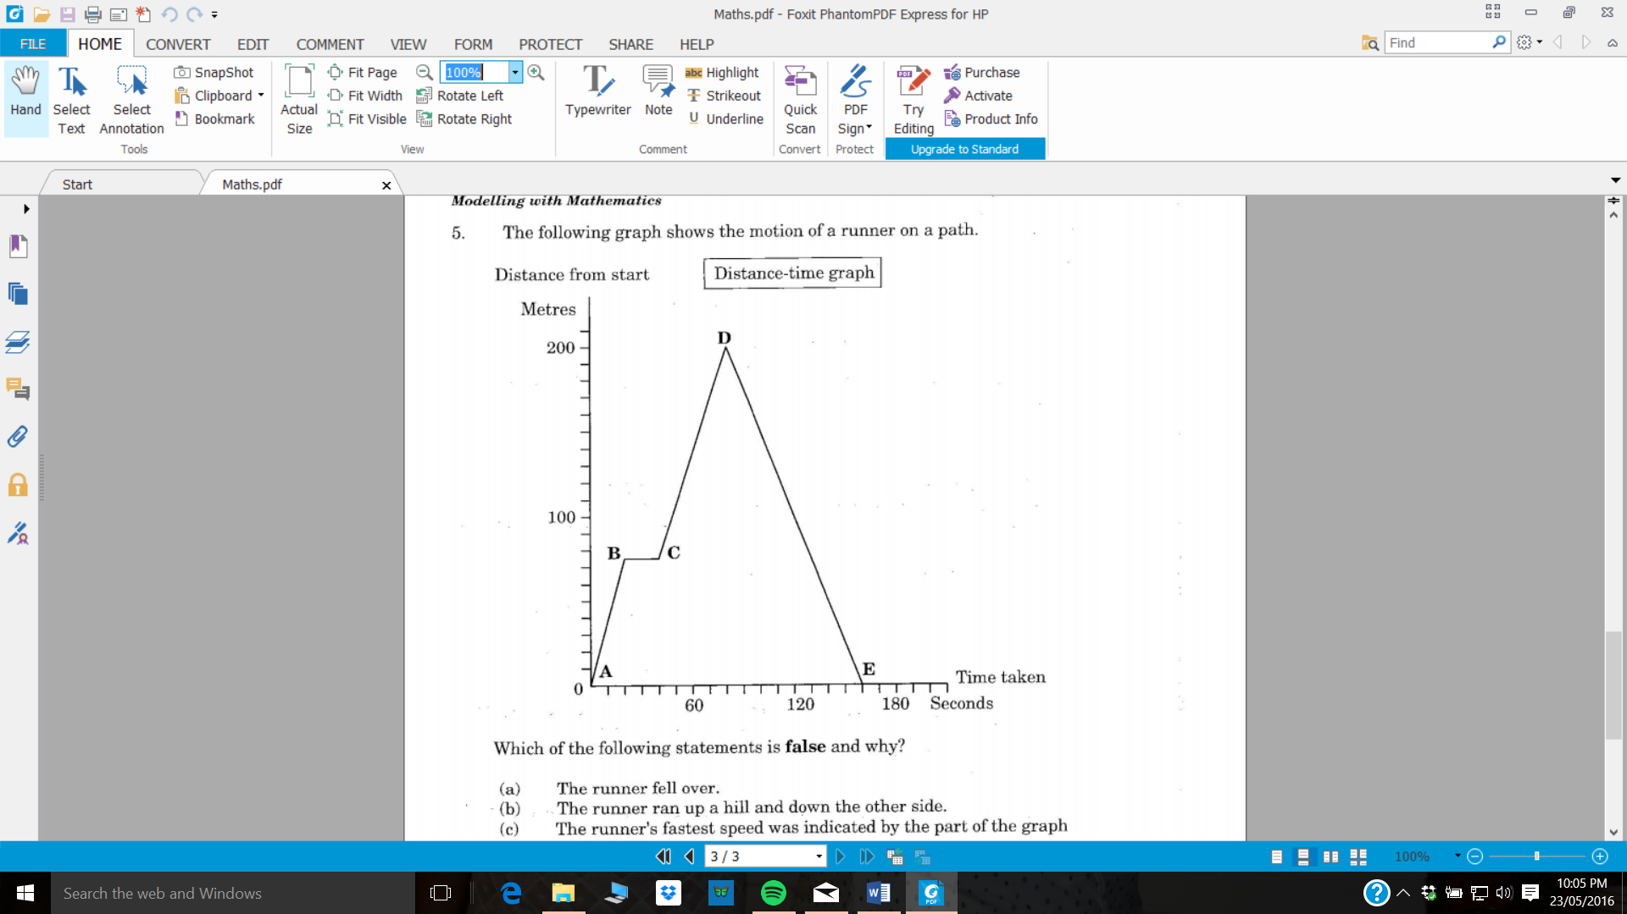

Which of the following statements is **false** and why? **[1]**

1. *The runner fell over.*
2. *The runner ran up a hill and down the other side.*
3. *The runner’s fastest speed was indicated by the part of the graph marked AB.*
4. *The runner’s average speed was the same as the speed indicated by the part of the graph marked DE.*

Reason:__________________________________________________________ **[1]**  
 __________________________________________________________

**Question 3 (3 marks)**

State the coordinates of each point.

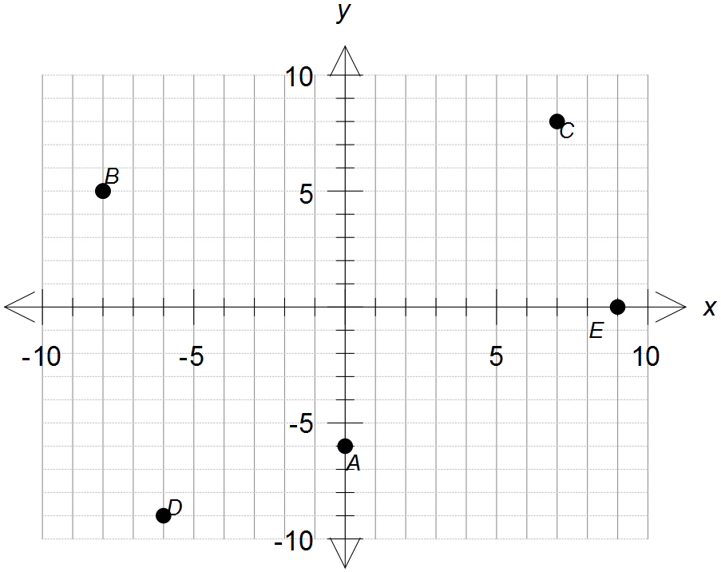

A

B

C

D

E

**Question 4 (5 marks: 1, 1, 2, 1)**

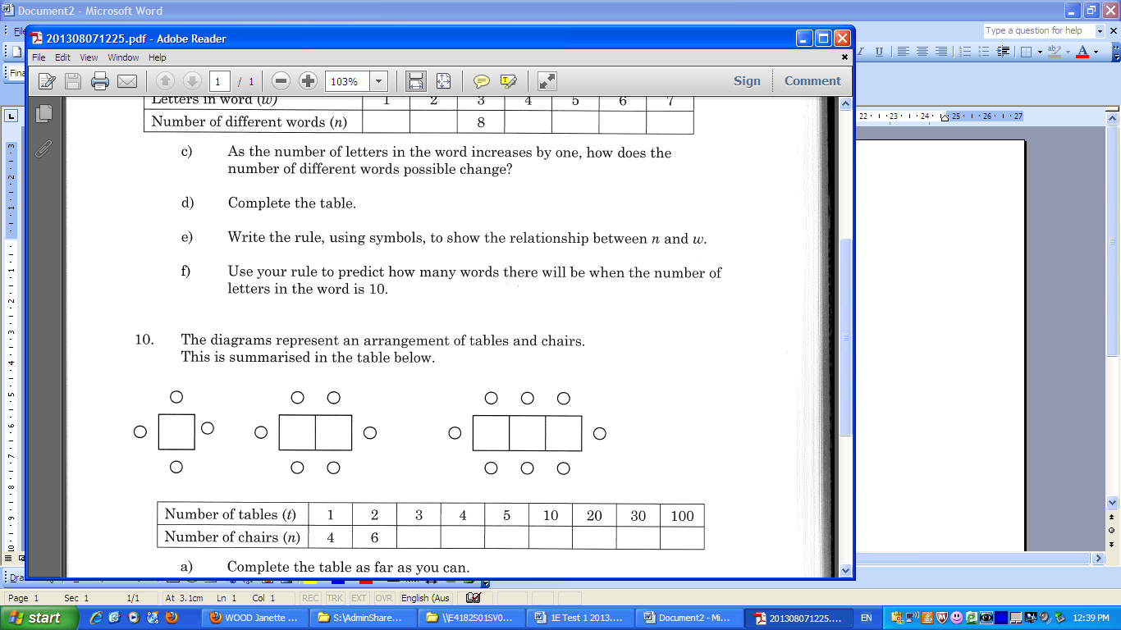The diagrams below represent an arrangement of tables and chairs.

This is summarized in the table below.

1. Draw the next diagram in the pattern. **[1]**
2. Complete the table for values for t = 3 and t = 4. **[1]**

|  |  |  |  |  |  |  |  |  |
| --- | --- | --- | --- | --- | --- | --- | --- | --- |
| Number of tables (t) | 1 | 2 | 3 | 4 | 5 | 10 | 20 | 100 |
| Number of chairs (n) | 4 | 6 |  |  |  |  |  |  |

c) Write a linear relationship linking (t) and (n) **[2]**

d) Complete the table above **[1]**

**Question 5 (11 marks: 3, 1, 1, 2, 1, 2, 1)**

The table below shows the length and diameter of a small sample of bird eggs from different species of birds.

|  |  |  |  |  |  |  |  |  |  |  |  |  |  |  |  |
| --- | --- | --- | --- | --- | --- | --- | --- | --- | --- | --- | --- | --- | --- | --- | --- |
| length (mm) | 95 | 18 | 29 | 70 | 66 | 11 | 86 | 101 | 15 | 135 | 43 | 147 | 150 | 153 | 140 |
| diameter (mm) | 62 | 13 | 21 | 47 | 42 | 8 | 60 | 70 | 13 | 81 | 34 | 110 | 124 | 133 | 89 |

1. Construct a scatterplot for the data. **[3]**



1. State the dependent and independent variables: **[1]**

Dependent : ________________ Independent : ________________

1. Describe the association between length and diameter for the dataset. **[1]**
2. Draw a line of best fit and use it to predict the diameter of an egg with a length of 50 mm. **[2]**
3. Predict the diameter of an egg with a length of 160 mm. **[1]**
4. Which answer is likely to be more reliable/accurate (d) or (e)? Explain why. **[2]**
5. Describe the trend of the data. **[1]**

**Question 6 (13 marks 2, 2, 3, 3, 3)**

The graph below shows the cost, based on the energy used, to transport bottled water from its source to the consumer. Ampac Trucking and Beta Trucking distribute water bottles to shops and charge for this service. Beta company’s cost ($*C*) per km (*d*) is shown on the graph.

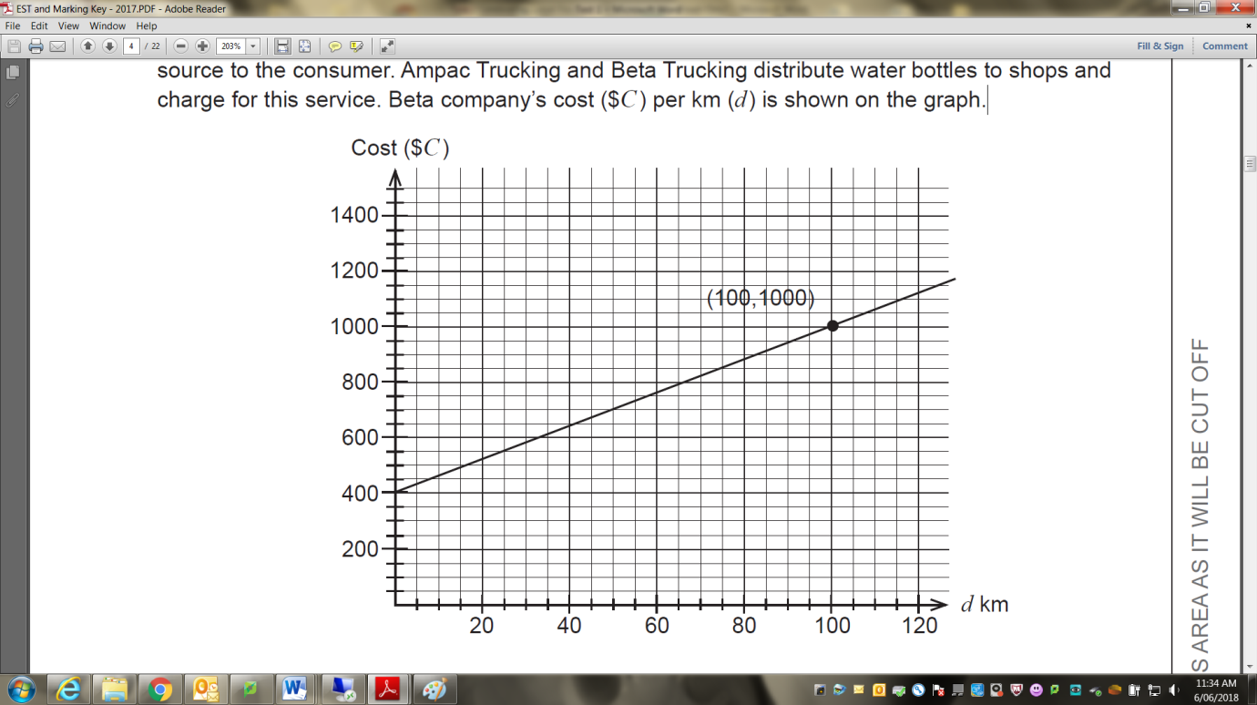

1. For Beta Trucking:
   1. Determine and describe the significance of the vertical intercept. **[2]**
   2. Determine the rate of change (related to the slope of the line). **[2]**
   3. Determine the linear relationship between cost ($*C*) and km (*d*) travelled. **[3]**

1. Ampac Trucking charge an initial cost of $600 and $3 per km as shown in the table below. Draw a graph of this relationship onto the previous page. **[3]**

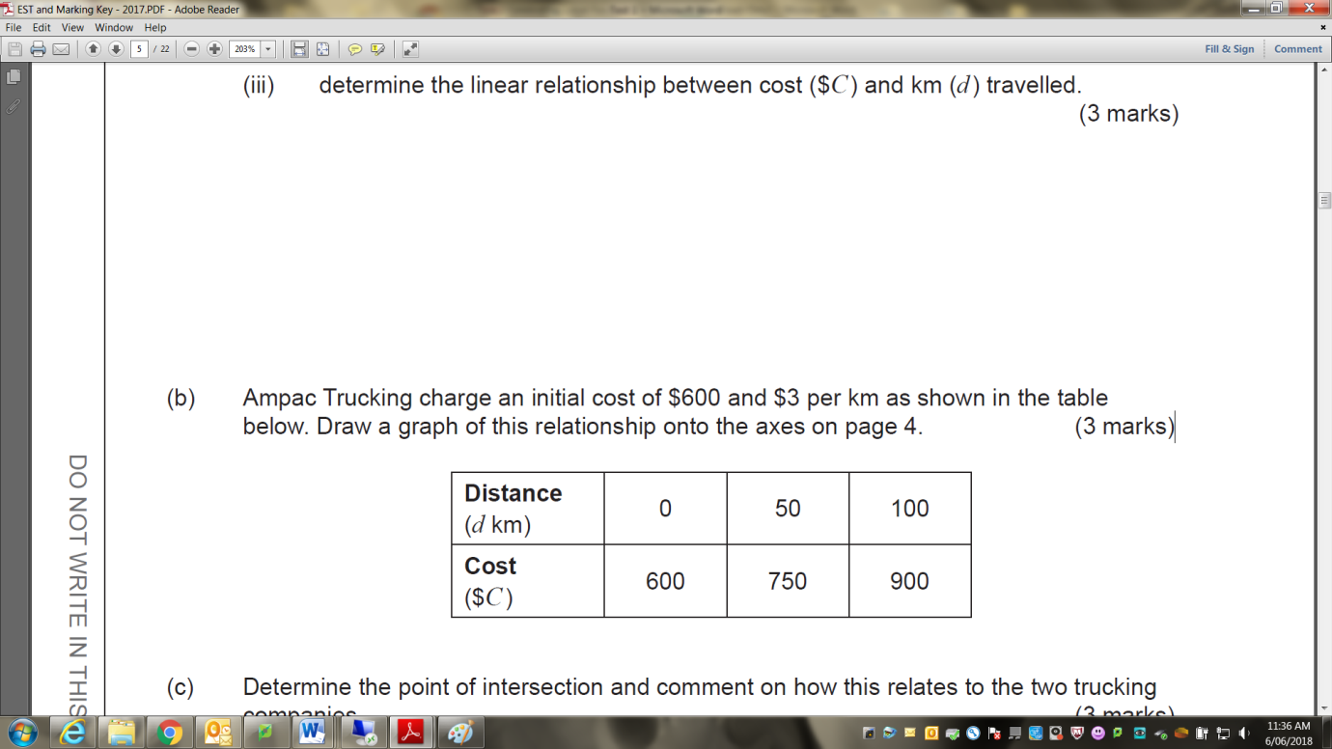

1. Determine the point of intersection and comment on how this relates to the two trucking companies. **[3]**

**Question 7 (9 marks 2, 1, 3, 1, 2)**

The scatterplot shows the cost ($) of 12 different brands of bottles of water and the distance travelled (km) from the water source to Perth.

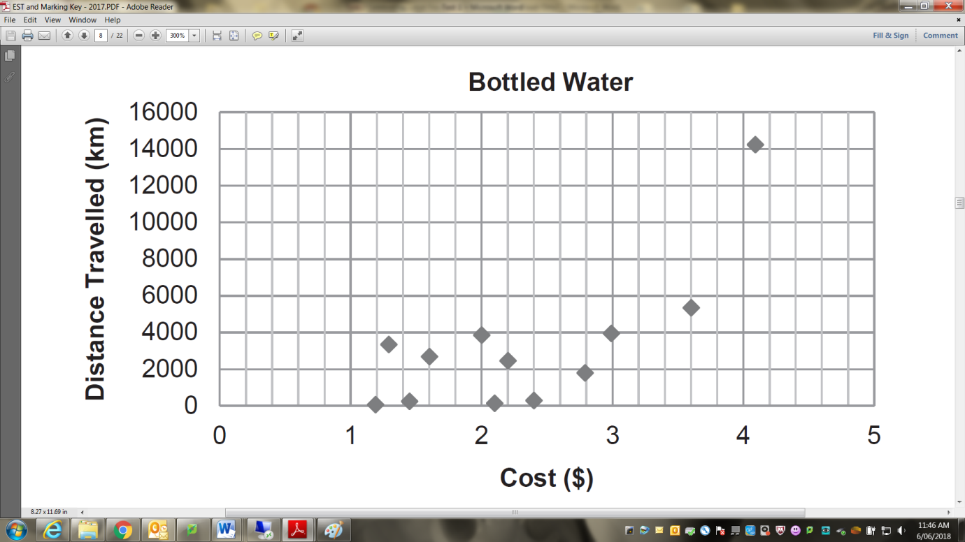

1. Describe the association between the variables for **all** of the given points in terms of direction and strength. **[2]**
2. A popular brand of water is sourced in France and travels the furthest.
   1. Identify this point on the graph. **[1]**
   2. Comment on how **not** including this point affects the association between the variables in terms of form and strength. **[3]**

* 1. Fit a trend line by eye to the graph (without the point identified in   
     part i.). **[1]**

1. A local newspaper publishes the amended graph from part (b) under the headline ‘The distance travelled by bottled water causes an increase in the sale price’. Do you agree with this statement? Use mathematical reasoning to justify your answer. **[2]**

**Question 8 (5 marks: 3, 2)**

The number of babies born each year in Kojonup District Hospital is as follows:

|  |  |
| --- | --- |
| **Year** | **Number of babies** |
| 2004 | 35 |
| 2005 | 47 |
| 2006 | 51 |
| 2007 | 60 |
| 2008 | 58 |
| 2009 | 62 |
| 2010 | 46 |
| 2011 | 50 |
| 2012 | 45 |
| 2013 | 42 |
| 2014 | 39 |

1. Graph the data as a line graph on the grid provided below. **[3]**

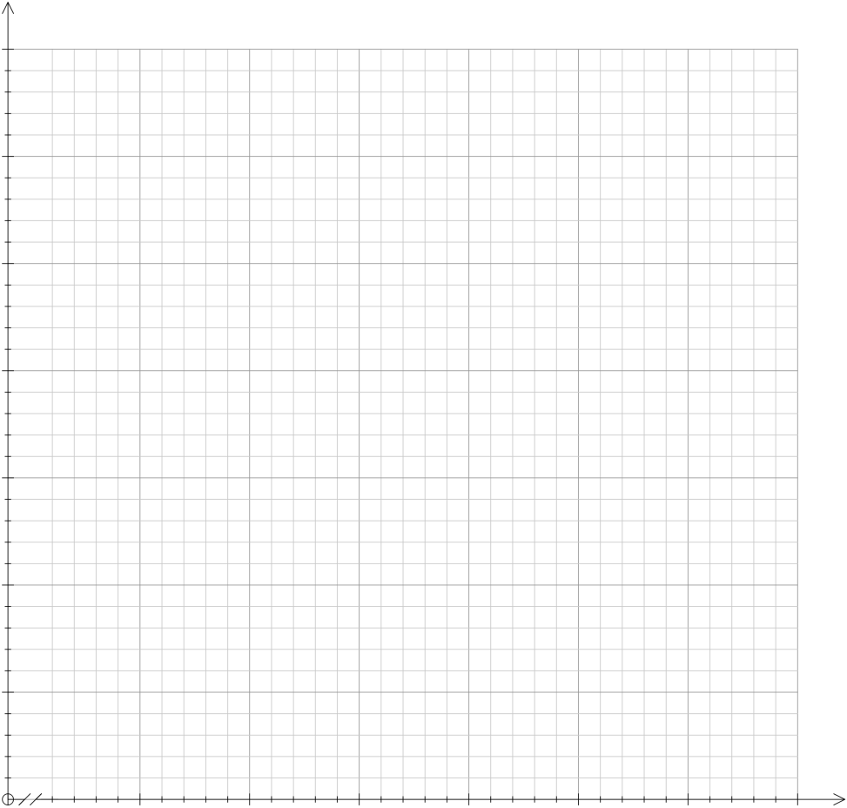

1. What comment can you make about the trend in the birth rate in this town? **[2]**

**END OF TEST**